Claire Homard  Interim Chief Officer (Education and Youth)  Prif Swyddog (Addysg ac leuenctid dros dro) | 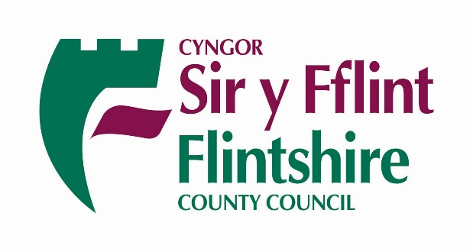
Parents/Carers and Guardians of  Brynford Community Primary School | Your Ref/Eich Cyf
 | Our Ref/Ein Cyf | CH/SchMod
 | Date/Dyddiad | 13 June 2018
 | Ask for/Gofynner am | Claire Homard
 | Direct Dial/Rhif Union | 01352 704134/4014

Dear Parents/Carers and Guardians,

School Modernisation Programme – Proposed amalgamation of Brynford Community Primary School and Lixwm Community Primary School

The Consultation Report for the Proposal to amalgamate Brynford Community Primary School and Lixwm Community Primary School will be available to view and download from Flintshire County Councils website today

http://www.flintshire.gov.uk/en/PDFFiles/Lifelong-Learning/Schools/School-Modernisation-Area-Schools-Review/BrynfordLixwm2018/Formal-Consultation-Report-ENG.pdf

Large print, Braille, alternative language and hard copy versions of the Consultation Report are available on request from the School Modernisation Team either by telephoning the number above or emailing 21stcenturyschools@flintshire.gov.uk

Flintshire County Council Cabinet Members will consider a Cabinet report on the Area Review Brynford and Lixwm on Tuesday 19 June 2018.

Yours Sincerely

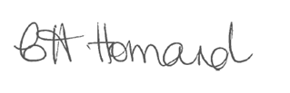

Claire Homard
Interim Chief Officer, Education & Youth

