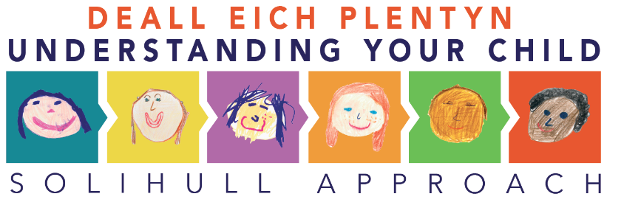

Roeddwn i eisiau rhoi gwybod i chi am gyrsiau ar-lein Dull Solihull sydd ar gael yn rhad ac am ddim rhwng Ebrill 2020 a Thachwedd 2022 i holl drigolion Gogledd Cymru.
Mae’r cyrsiau yn addysgiadol ac yn ddiddorol iawn! Maen nhw'n edrych ar fabis / plant / plant yn eu harddegau o ran datblygiad ymennydd, chwarae, dulliau magu plant, cysgu, pyliau o dymer ddrwg, cyfathrebu a llawer mwy!
Yn y cyrsiau, edrychir ar iechyd a llesiant emosiynol rhieni, neiniau a theidiau, gofalwyr a’r babanod/plant/plant yn eu harddegau. Mae'r cyrsiau'n seiliedig ar dystiolaeth, fe'u hysgrifennwyd gan weithwyr proffesiynol cofrestredig, ac fe'u cydnabyddir gan ddarparwyr y GIG a'u hachredu gan yr Adran Addysg.
Rhennir y cyrsiau yn bedair adran, gallwch wneud pob un neu ddewis pa un sydd fwyaf perthnasol i chi:
- Deall Beichiogrwydd, Esgor, Genedigaeth a’ch Babi
- Deall eich Babi
- Deall eich Plentyn
- Deall Ymennydd eich Plentyn sydd yn ei Arddegau (mae’n gwrs byrrach)
Mae cyfoeth o awgrymiadau a gwybodaeth ddefnyddiol ym mhob un o’r cyrsiau. Mae rhwng 9–11 modiwl ym mhob cwrs. Mae pob un yn cymryd tua 20 munud i'w gwblhau, ac mae ganddyn nhw ddigon o amrywiad o weithgareddau rhyngweithiol, cwisiau, clipiau fideo a thaflenni ymarferol.
Byddwn yn argymell eich bod yn gwneud o leiaf un sesiwn yr wythnos. Mae gweithgareddau y gallwch chi roi cynnig arnyn nhw rhwng eich sesiynau ar-lein hefyd. Unwaith y byddwch wedi cwblhau pob cwrs, byddwch yn derbyn tystysgrif.
Os oes diddordeb gennych mewn ymchwilio ymhellach i’r cyrsiau hyn eich hun, ewch i www.inourplace.co.uk i gofrestru a nodi ein cod mynediad unigryw ar gyfer Gogledd Cymru, sef NWSOL. Hefyd mae gan Solihull Approach Gogledd Cymru dudalen Facebook a Twitter Solihull Approach Gogledd Cymru ydy eu henw ar y ddau lwyfan cymdeithasol yma.
Rwy’n gobeithio y byddwch yn mwynhau’r cyrsiau ac mae croeso i chi rannu’r cod mynediad â ffrindiau neu berthnasau sy’n drigolion yng Ngogledd Cymru.
Os hoffech chi roi gwybod i ni beth oeddech chi'n ei feddwl o'r cyrsiau, anfonwch unrhyw adborth neu sylwadau at: nwsol@wales.nhs.uk

We are writing to let you know about Solihull Approach online courses that are available exclusively free of charge from April 2020 to November 2022 for all residents of North Wales.
The courses are really informative and interesting! They look at the baby / child’s / teenager brain development, play, styles of parenting, sleep, temper tantrums, communication and many more!
Emotional health and wellbeing of parents, grandparents, carers and the infant/child/teenager are explored within the courses. The courses are based on evidence, have been written by registered professionals, and are recognised by NHS providers and accredited by the Department of Education (DfE).
The courses are split into 4 sections, you can do them all or choose which one’s are most relevant to you:
      - Understanding Pregnancy, Labour, Birth and your Baby
      - Understanding your Baby
      - Understanding your Child
      - Understanding your Teenagers Brain (is a shorter course)
There is a wealth of useful tips and information within all of the courses, there are between 9 – 11 modules within each course. Each takes around 20 minutes to complete, and have plenty of variation from interactive activities, quizzes, video clips and practical handouts.
I would recommend that you do at least one session a week, there are activities that you can try out in between your online sessions as well. Once you have completed each course you will receive a certificate.
If you are interested in exploring these courses further yourself, please go to www.inourplace.co.uk to register and enter our exclusive access code for North Wales which is NWSOL. Also Solihull Approach North Wales have Facebook and Twitter pages which you could follow both social media platforms are called Solihull Approach North Wales.

I hope you enjoy the courses and please do feel free to pass on the access code to any friends or relatives who are residents within North Wales.
If you would like to let us know what you thought of the courses, please send us any feedback or comments to: nwsol@wales.nhs.uk

