Class 3 VE Day themed Home learning activities

**Science and Technology**

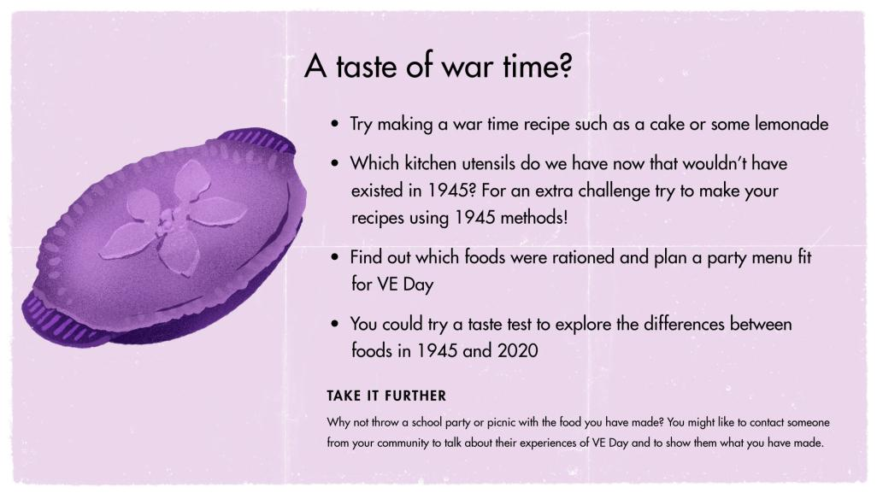

**Expressive Arts**

Get creative and design some bunting or decorations for your VE celebrations. Templates can be found on Google Classroom or Purple Mash.

**Health and Well-being/Technology**

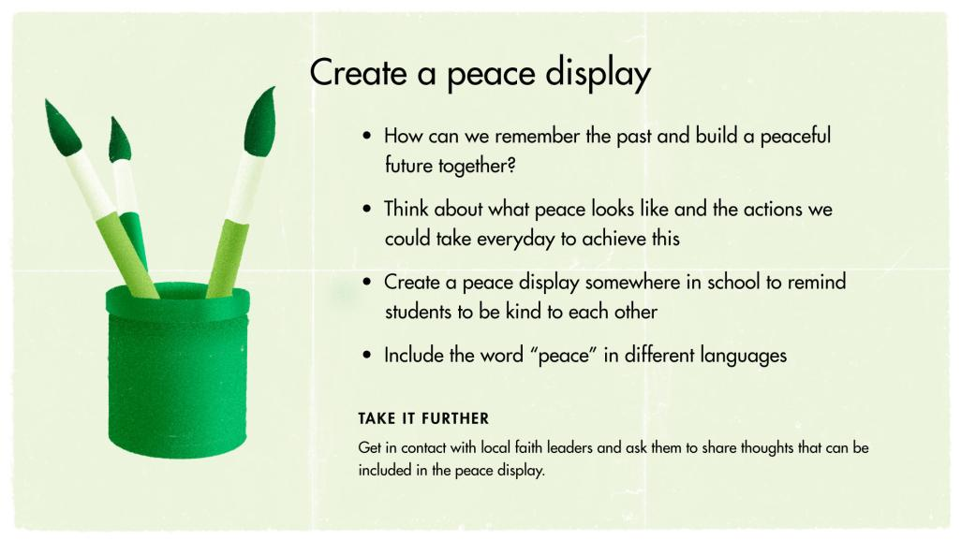

**Health and Well-being/Technology**

Celebrate and recreate VE Day with your family on Friday 8th May. Dress up in 1940s style clothes, learn some 1940’s songs, learn 1940’s dances like the Lindy hop and play games from the 1940s.

Ext -take photos and create a memory book to look back on in years to come.

**Expressive Arts/Humanities**

Design a VE Day Medal and explain what it represents. View worksheet on either Google Classroom or Purple Mash. Alternatively, visit [www.Twinkl.co.uk](http://www.twinkl.co.uk) for ‘Design a VE Day Medal worksheet’.

**Humanities/Mathematics/English/Technology**

Plan your own VE Day celebrations for Friday 8th May. What will you eat? How much will it cost? Can you plan some games, songs and dances to do on the day? Create a plan using Google Classroom, PM or write in your home learning books.

**Language, Literacy and Communication**

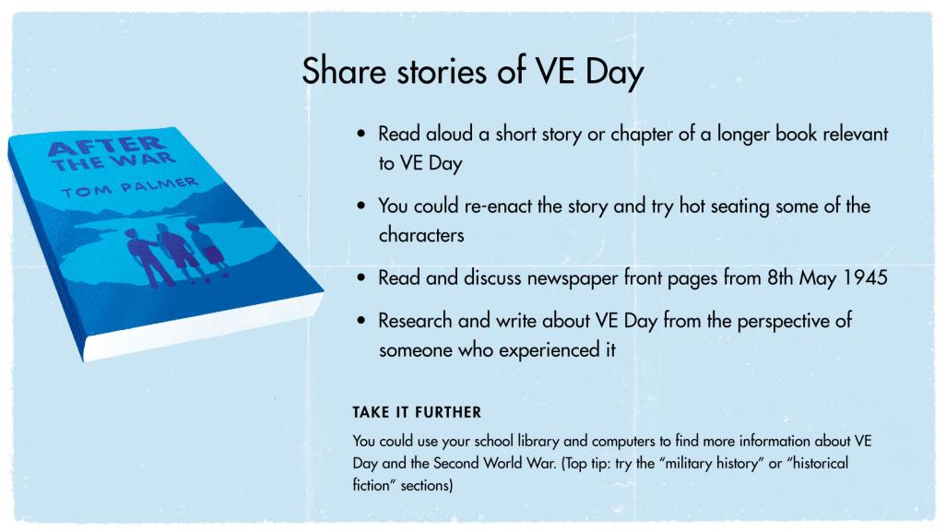

**Humanities/Language, Literacy and communication**

Visit: <https://www.bbc.co.uk/teach/class-clips-video/history-ks2-ve-day/z7xtmfr> to learn about VE Day which is being celebrated this Friday (8th May). View and answer the worksheet on Google Classroom or Purple Mash.