Brynford CP School
Brynford
Holywell
Flintshire
CH8 8AD
01352 713184

Ysgol Gynradd Brynffordd
Brynffordd
Treffynnon
Sir y Fflint
CH8 8AD
01352 713184
‘Every child, every chance, every day’
‘Pob plentyn, pob cyfle, pob dydd’
Mrs Rachel Critchell B.A.HONS P.G.C.E, NPQH
bfmail@hwbmail.net

Returning to School
Parental Information

The School Day

The Catch Up and prepare for Summer and September School Day will have staggered start and finish times which will be confirmed via email with your child/rens catch up sessions.

Please ensure you arrive promptly. If you arrive after your designated time you must wait at the gate and telephone the school office. Either Mrs Critchell or Mrs Prytherch will collect your child from the gate.

If at any point you decide your child will not be attending the catch up sessions, please notify the school with your child / children’s name and the reason for absence by telephone 01352 713184 or email bfmail@hwbmail.net

Where possible siblings will attend on the same day.

The HUB will be open from 8am until 5.30pm for authorised and agreed access. This is done through the existing process, request for access and completion of the Employers Information Form. (available from school). Parents MUST notify the school in advance by email of their child/rens drop off and collection time.
ONLY Children and Staff are able to enter the School site. Access for Parents, Carer’s, Visitors etc is strictly by appointment only.

Pupils are to wear their own clothes (not uniform). These clothes should be suitable for indoor / outdoor learning and appropriate for the day’s weather conditions. Long hair must be tied back and no jewellery can be worn.

Entry and Exit to and from School will be for Pupils only via the following access points.

HUB & Class 3 Groups (year 5 and 6): Enter through the car park gate onto the school yard, walk to the designated waiting point, ensuring social distancing.

Class 2 Groups (year 3 and 4): Enter through the front pedestrian gate onto the school yard, walk to the designated waiting point, ensuring social distancing.

Class 1 Groups (reception, year 1 and 2): Enter through the side pedestrian gate onto the school yard, walk to the designated waiting point, ensuring social distancing.

Designated waiting points will be supervised by staff at the start and end of the day.

All children will be provided by Newydd Catering with a cold packed lunch and drink specific dietary requirements can be catered for. Please ensure a drinks bottle is in your child’s bag each day as we cannot provide cups etc.

HUB children MUST bring their own healthy snack. (NO PEANUTS DUE TO ALLERGIES). No snacks will be provided by school.

Children may bring a pack of tissues and hand sanitiser in their bag, these items will be for their own use only.

Any necessary items brought to school cannot be handled by staff. Please ensure drinks bottles can be used by the children themselves. Sun cream must be applied before the children come to school.
Children MUST NOT bring any unnecessary items to school with them.

If any child shows any signs of illness, they will be separated and wait in the School Office supervised by a member of staff in PPE. Parents will be contacted immediately and will be required to collect their child immediately.
- Children should not attend school:
- if they feel unwell, have any of the three identified COVID-19 symptoms (a new continuous cough, a high temperature or loss of taste or smell) or they have tested positive to COVID-19 in the past 14 days
- live in a household with someone who has symptoms of COVID-19 or has tested positive to COVID-19 in the past 14 days.

School will prevent the sharing of food, drink, utensils, equipment and toys. Equipment, toys and surfaces will be cleaned and disinfected more frequently. Each child will have designated equipment on each desk for their own use.
As far as possible, pupils and staff will be spaced 2 metres apart at all times.

In preparation for your child/children returning to school Parents/carers please discuss these messages at home, reminding your child/children to support the school in establishing good routines for handwashing and social distancing. This will help to make the process smoother for everyone.
This means:
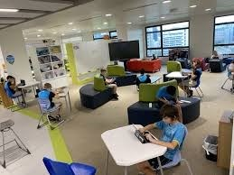
Sitting children at desks that are 2 metres apart. Each Child will have all the supplies they need on their desk for the period they are in school.
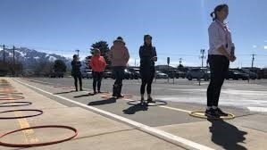
Ensuring everyone queues and walks 2 metres apart
Follows the one-way system around school
Eats at designated desks remaining 2 metres apart at all times.

Keeping 2 metres apart when in the playground or doing any physical exercise

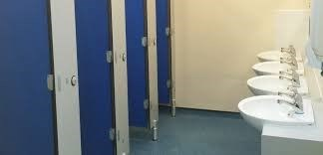
Visiting the toilet one after the other. Each Class will have a designated cubicle. Urinals will be shared but not touched.

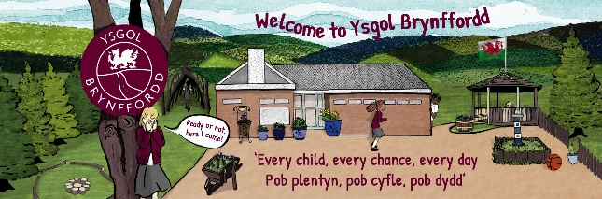
Each group will have a designated area for any break times or outdoor learning. Break times will be staggered.

Antibacterial wipes and spray will be used throughout the day with all classes and toilets being thoroughly cleaned at the end of each school day.

Children must arrive at school by walking or in private vehicles only.
Class groups will be small and all groups will remain with the same staff member in well ventilated rooms whilst in School. The Hub group will be staffed on a rota basis.
Lunch and snack will be eaten at the child’s designated desk, with break times and outdoor learning taking place in the classes designated area. All outdoor learning and lunchtimes will be staggered. Regular handwashing routines will be established.
All staff and children will:
- Wash their hands with soap and water for 20 seconds frequently.
- Will be encouraged not to touch their faces
- Use a tissue or elbow to cough or sneeze and bins for tissue waste
- All staff will ensure help is available for children and young people who have trouble washing their hands

Increased cleaning of surfaces in classrooms, including desks and handles, and within toilet blocks and changing rooms
For children and young people with an individual care plan, teaching staff as well as parents will work together to decide how best to continue supporting these children and young people to stay healthy.
However much want to help, they will be unable to touch anything pupils bring to school. Please ensure pupils can open and access any items they bring.
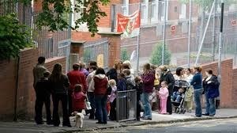
Parents MUST NOT gather at entry and exit points or anywhere outside the school and MUST socially distance at all times.
General Information Preventing Coronavirus

The virus that causes COVID-19 is mainly transmitted through droplets generated when an infected person coughs, sneezes or speaks.
These droplets are too heavy to hang in the air. They quickly fall on floors or surfaces. The advice for schools, colleges and childcare settings is to follow steps on social distancing, handwashing and other hygiene measures and cleaning of surfaces.
The Department for Education and Public Health England and Wales state.
Children are likely to become infected with coronavirus (COVID-19) at roughly the same rate as adults, but the infection is usually mild.
The most common symptoms of coronavirus (COVID-19) are a new, continuous cough or a high temperature (over 37.8 degrees)
For the vast majority of children and staff, coronavirus (COVID-19) will not cause serious illness
To help ensure that the risk of virus spread for both staff and children is as low as possible, School expect all should follow the information laid out below:
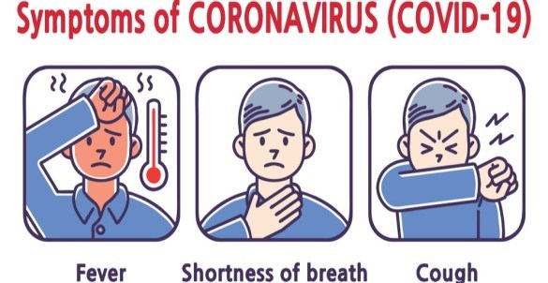
Children, parents, carers or any visitors, such as suppliers, MUST NOT enter the School if they are displaying any symptoms of coronavirus (COVID-19)
PARENTS/CARERS MUST NOTIFY THE SCHOOL IF ANY SYMPTOMS ARE DISPLAYED.

Social Distancing Guidelines
Social distancing within school settings with very young children is harder to maintain. Staff will implement the above measures as far as they are able, whilst ensuring children are kept safe and well cared for within their settings.
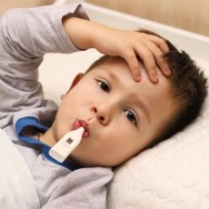
Parents/Carers have a responsibility to monitor their own child’s health and MUST NOT send their child to school if they or themselves have a persistent cough or high temperature.
Foundation Phase
Teachers and other staff will use age and developmentally appropriate ways to encourage children to follow social distancing, hand-washing and other guidance, including through games, songs and stories. Parents/carers must reinforce these messages at home, reminding their children to support the school in establishing good routines for handwashing and social distancing.
We hope that you find this information informative, helpful and reassuring.

If you have any questions or require further information, please email bfmail@hwbmail.net or telephone the School on 01352 713184.

