LO: To analyse and interpret data
Look at the data below then answer the questions
Rainfall in Brazil
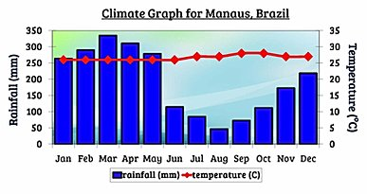
Rainfall in Cardiff
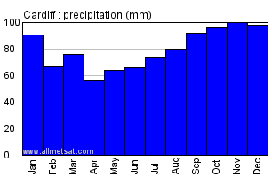
Questions
- Which month was the wettest in Brazil?
- Which month was the wettest in Cardiff?
- What is the difference of the wettest months between Brazil and Cardiff?
- Which month had the least amount of rain in Brazil?
- Which month had the least amount of rain in Cardiff?
- What is the difference between the months that had the least amount of rain in Brazil and Cardiff?
- What is the difference between the rainfall for Brazil and Cardiff in January?

