Claire Homard  Chief Officer (Education and Youth)  Prif Swyddog (Addysg ac leuenctid) | 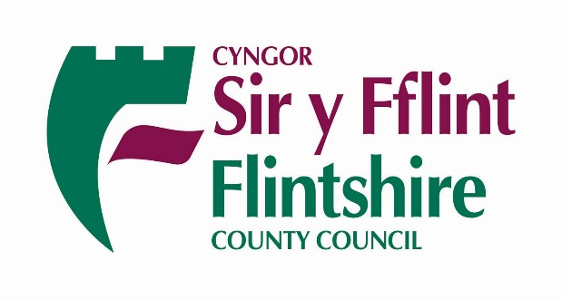
To Parents of All Nursery Pupils | Your Ref/Eich Cyf
 | Our Ref/Ein Cyf
 | Date/Dyddiad | September 2020
 | Ask for/Gofynner am | Primary School Admissions
 | Direct Dial/Rhif Union | 01352 704073

Dear Parent

Admission to Primary School September 2021

Your child will be starting in the reception class in September 2021. You now have the opportunity
to express a preference for your preferred school. Please apply on-line at www.flintshire.gov.uk/schooladmissions and ensure you receive an e-mail to confirm that your application has been submitted. If you do not receive a confirmation e-mail please re-submit.

In order to assist you with your decision, all schools will produce a prospectus giving full details of the school.

The Local Authority provides a ‘Guide to Education Services 2021’ detailing the admissions procedure. A list of all schools is also available.

The ‘Guide to Education Services 2021’ is available on our website, www.flintshire.gov.uk/schooladmissions.

It is important that you read the ‘Guide to Education Services 2021’ before completing your preference form so that you are aware of the oversubscription criteria and the school transport policy.

The timetable for primary school admissions is as below:-

Admission forms available to parents | Parents’ consideration period | Closing date for receipt of forms | Allocation places period | Parents informed by:
28/09/2020 | 28/09/20 – 20/11/20 | 20/11/20 | 23/11/20 – 26/02/21 | 16/04/21

All applications must be received by the closing date. Any applications received after the closing date will be treated as late applications and considered after those received on time.

Yours sincerely

Sharon Wainwright – Primary School Admissions

