Claire Homard  Chief Officer (Education and Youth)  Prif Swyddog (Addysg ac leuenctid) | 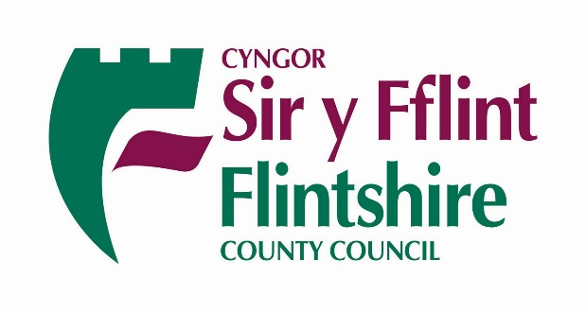
 | Your Ref/Eich Cyf
 | Our Ref/Ein Cyf | CH
 | Date/Dyddiad | 16th December 2020
 | Ask for/Gofynner am | Claire Homard
 | Direct Dial/Rhif Union | 01352 704190
Dear Parents and Carers

We all have a role to play in the fight against Coronavirus!

Over the past few months a number of Flintshire schools have been affected by pupils who have been forced to self-isolate, due to positive cases in their school ‘bubbles’.

The vast majority of families have complied with the requirements set out by Public Health Wales and the Welsh Government. However, with Christmas fast approaching it’s important to remind ourselves of why we still need to adhere to these rules.

Over recent weeks there has been a steady increase in the numbers of people testing positive to COVID-19 in the county. Colleagues in schools have picked up on some concerning trends and misconceptions, which goes against the current health protection guidance. Some of the main areas of concern are:

- Lack of adherence to self-isolation rules, when confirmed as a positive case or awaiting test results, some examples seen in Flintshire schools are:
  - Adults with symptoms and whilst waiting for their test result to come through sending and picking up their children from school
  - Childcare being provided by adults who are contacts of positive cases and should be self-isolating
  - Particularly for older pupils, not understanding how a bubble and the need to self-isolate works. For instance, carrying on with part time jobs, socialising with the bubble contacts.
- Children mixing outside school time – sleepovers, birthday parties, play dates, park mixing, family parties. School bubbles only relates to the school – not outside. Also:
  - Shared childcare out of school time – unregistered childminders taking children back with their children from school, also grandparents, aunties and uncles.
  - Lift sharing (both school staff and parents taking other people’s children to school) – this has caught several schools out.

With concern also being raised by Welsh Government and the potential for more lockdowns in the future, we ask that everyone in Flintshire does their part to keep our County safe.

We urge all families to be vigilant and stay safe over the upcoming holidays. The advice from Welsh Government remains in place and can be viewed here – https://gov.wales/coronavirus and advises:

Keep Wales safe:

- stay out of each other’s homes, except in very limited circumstances
- try to limit how many different people you meet
- maintain social distancing
- wash your hands regularly
- work from home if you can

Leader of the Council and Cabinet Member for Education and Youth, Councillor Ian Roberts, said:

“These are not “normal” times and coronavirus is active in all of our communities. We all need to work together to keep Flintshire safe and avoid meeting people from outside our household, wear face coverings and follow the rules that are in place to keep us all safe.”

Best wishes for a peaceful and safe Christmas.

Yours sincerely

Claire Homard

Claire Homard
Chief Officer, Education & Youth

