Claire Homard  Chief Officer (Education and Youth)  Prif Swyddog (Addysg ac leuenctid) | 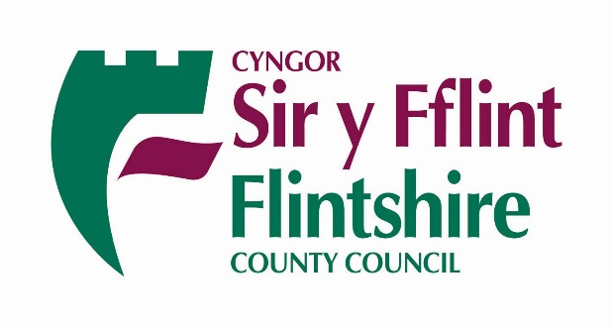
For the attention of:  Parents / Carers | Your Ref/Eich Cyf
 | Our Ref/Ein Cyf | CH
 | Date/Dyddiad | 5 February 2021
 | Ask for/Gofynner am | Claire Homard
 | Direct Dial/Rhif Union | 01352 704190
Dear Parents/Carers
As you will be aware, COVID-19 continues to pose a significant risk to the health of the population and Wales remains in a Tier 4 lockdown.
Tight restrictions remain in place in all aspects of daily life including for schools. Schools are directed to only provide face to face learning for those learners identified as vulnerable and those whose parents are defined as critical workers. Face to face education is only to be offered where no suitable alternative provision could be made for children to remain safely at home.
Alert level 4 means that:
- people must stay at home, except for very limited purposes
- people must not visit other households, or meet other people they do not live with
Despite the significantly reduced numbers of pupils attending its schools, we are still seeing a number of positively tested cases involving pupils who are accessing face to face provision. When we have a positive case, this results in that bubble of pupils being sent home to self-isolate for 10 days. This also puts the school workforce who are caring for them at risk.
This whole experience can be very disruptive for critical worker parents who really need to rely on this provision for their child/children to enable them to do their job – jobs which we will all depend on such as frontline healthcare workers and social care workers.
When children chat about things that are happening outside of school to their teachers, which is quite normal, we hear stories of some families not abiding by the rules and are socially mixing. These stories are supported by information gathered by the Test, Trace and Protect Team who follow up with calls to people who have tested positive who are asked to identify their close contacts. Breaches of the guidance helps the virus spread.
Where a school has strong evidence that families who are accessing face to face provision are not following the guidance, the offer of that place may be withdrawn.
The Council is asking for everyone to play their part and follow the guidelines to keep our children and our school workforces safe.
https://gov.wales/alert-level-4-frequently-asked-questions
Yours sincerely
Claire Homard
Claire Homard, Chief Officer Education & Youth

