Brynford CP School
Brynford
Holywell
Flintshire
CH8 8AD
01352 713184

Ysgol Gynradd Brynffordd
Brynffordd
Treffynnon
Sir y Fflint
CH8 8AD
01352 713184
‘Every child, every chance, every day’
‘Pob plentyn, pob cyfle, pob dydd’
Mrs Rachel Critchell B.A.HONS P.G.C.E, NPQH
bfmail@hwbmail.net
Returning to School
Parental Information

The School Day

- In March the School Day will start at 8:55am.
- Reception pupils arrive 8:55am, leave 3:15pm.
- Nursery and Early Entitlement pupils will arrive at 12:45pm and leave at 3.15pm.
- Year 1 and 2 will arrive at 9:00am and leave at 3:20pm.
- Year 3 and 4 pupils will arrive at 8:55 and leave at 3:15
- Year 5 and 6 pupils will arrive at 9:00 and leave at 3:20
- Please ensure you arrive promptly. If you are late arriving, you must wait at the gate and telephone the school office. Either Mrs. Critchell or Mrs. Prytherch will collect your child from the gate.
- All children should attend school from March 15th if they are well. Latest advice regarding shielding adults and children will be adhered to. However, if your child is unwell, please notify the school with your child / children’s name and the reason for absence by telephone 01352 713184 or email bfmail@hwbmail.net
- ONLY children and Staff are able to enter the School site. Access for parents, carer’s, visitors etc. is strictly by appointment only.
- Pupils are to wear school uniform in March apart from P.E days, when children should come to school dressed in PE kit. Long hair must be tied back and no jewelry can be worn.

P.E days will be as follows;

- Nursery/ Reception; Monday (From 1st March.)

- Class 1 Wednesday. (From 3rd March.)

- Class 2 (Years 3 and 4) Tuesday and Thursday (from 15th March)

- Class 3 (Years 5 and 6) Monday and Thursday (from 15th March.)

PE kits should consist of black leggings/ black jogging bottoms, white t-shirt, school jumper, trainers.
PARENTS / CARERS MUST WEAR FACE MASKS AND ENSURE THEY ARE SOCIALLY DISTANCING AT DROP OFF AND COLLECTION TIMES

- Entry and Exit to and from School will be for pupils only via the following access points. Designated waiting points will be supervised by staff at the start and end of the day.

- Reception, Year 1 and 2: Enter through the front pedestrian gate, onto the school yard, walk to the designated waiting point, ensuring social distancing.

- Nursery and Early Entitlement Children: Wait at the front pedestrian gate until collected by the Teacher. They will leave through the front pedestrian gate.

- Key Stage 2 Pupils:

- Years 3 and 4: Wait on the public foot path in front of the Car Park (to the right hand side of the main gate.) The children will be collected by the member of staff and enter via the car park access gate at the above times.

- Years 5 and 6: Wait by the ‘social distance sign’ on the public footpath, socially distanced from the group in front. The children will be collected by the member of staff and enter via the car park access gate at the above times.

- Snack will not be provided by school so children can bring their own healthy snack. This should be in packaging that is easily opened by your child. NO NUT products please.

- Children may bring a pack of tissues and hand sanitizer. These items will be for their own use only.

- Please only bring necessary items to school. These include a drinks bottle, medication and a coat. PLEASE DO NOT send in school bags.

- School will minimise the sharing of food, drink, utensils, equipment and toys. Equipment, toys and surfaces will be cleaned and disinfected more frequently. Each child will have designated equipment for their own use.

- As far as possible, pupils and staff will maintain some social distancing. This is within school and outside.

- Classrooms will be organised with consideration for social distancing whenever possible. Staff will maintain 2 metre social distancing whenever possible.

- Movement through the corridor will be minimised and a one-way system is in operation. Class bubbles will move around school at different allocated times.

Procedures for illness
If any child shows any signs of illness, they will be separated from other children and will wait in the School Office or Octagon, supervised by a member of staff wearing PPE. Parents will be contacted immediately and will be required to collect their child immediately. Surfaces that learners or staff with symptoms have come into contact with will be carefully and thoroughly cleaned.

Children or staff should not attend school:
- if they feel unwell, have any of the four identified COVID-19 symptoms (a new continuous cough, a high temperature or loss of taste or smell) or they have tested positive to COVID-19 in the past 10 days
- live in a household with someone who has symptoms of COVID-19 or has tested positive to COVID-19 or have been identified as a close contact of a positive COVID-19 case in the past 10 days.
- If you have any reoccuring symptoms at any point after ending self isolation. You must then follow the guidance on self isolation again. The same rules apply for anyone in your household or extended household.
Test,Trace,Protect works by;
Testing those people who have coronavirus symptoms, asking them to self isolate from family, friends and their community whilst taking a test and waiting for a result. People can apply for a test for themselves or someone in their household with symptoms. This includes adults and children including the under 5’s.
Tracing those people who have been in close contact with people that have tested positive for the virus, requiring them to self isolate.
Ensuring that if the symptoms are not due to coronavirus, individuals and their contacts can cease their period of self-isolation and get back to their normal routines immediately once the negative test result is known.
Providing advice and guidance particularly if the person who has symptoms ot their contacts were previously in the ‘shielding group’ or are in the increased risk group.
A positive test on site does not require closure of the site. The process of testing and contact tracing is part of the ‘new normal.’
All staff now take twice weekly lateral flow tests as an addtional safety precaution.
Clusters and Outbreaks
A potential cluster is defined as two or more cases of COVID-19 among learners or staff in an educational setting within 10 days or an increased rate of absence due to suspected or confirmed cases of COVID-19
A potential outbreak is defined as two or more confirmed cases of COVID-19 among learners or staff who are direct close contacts, proximity contacts or in the same ‘bubble’ in the school/setting within 10 days.
If any Cluster or Outbreak is identified, the Regional Multi Agenct Test Trace and Protect Team or Outbreak Team will be contacted.
In preparation for your child/children returning to school in March
Parents/carers please discuss these messages at home, reminding your child/children to support the school in continuing to establish good routines for handwashing and social distancing.

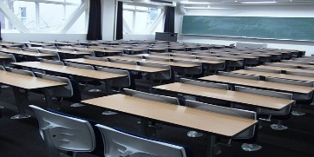
For February; This means;
The classrooms will be organised with due regard for social distancing. Children will remain in class bubbles. These bubbles will not mix. Staff will maintain 2 metre social distancing wherever possible.

Each child will have all the supplies they need in their classroom for the period they are in school. Please do not bring unnecessary items into school. A water bottle, medication, snack and packed lunch bag is all that is required.
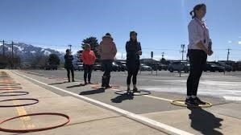
Everyone queues and maintains some social distancing at the start and end of the day.
We all follow the one-way system around school
Eat on designated tables (class bubbles) maintaining social distancing.

We maintain some social distancing when in the playground or doing any physical exercise.

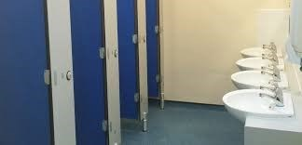
Visiting the toilet one after the other. Each Class will have a designated cubicle. Urinals will be shared but not touched.

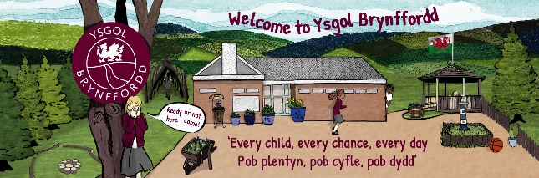
Each group will have a designated area for any break times, lunchtimes or outdoor learning. Break-times will be staggered.

Antibacterial wipes and spray will be used throughout the day with all classes and toilets being thoroughly cleaned at the end of each school day.

Children must arrive at school by walking or in private vehicles only. Parents/ carers should not be transporting children from different families.
Class groups will remain with the same staff members in well ventilated rooms whilst in School. They will have designated play areas on the yard and will remain in these class groups throughout the day.
Lunch and snack will be eaten at designated group tables, with break times and outdoor learning taking place in the classes designated area. All outdoor learning and lunchtimes will be staggered. Regular handwashing routines will be established.
All staff and children will:
- Wash their hands with soap and water for 20 seconds frequently. (e.g. on entry to the building, before and after eating, after break-times/lunchtimes, before and after visits to the toilet.
- Will be encouraged not to touch their faces
- Use a tissue or elbow to cough or sneeze and use designated bins for tissue waste
- All staff will ensure help is available for children and young people who have trouble washing their hands
- Staff will wear face masks in school.
Cleaning
There will be increased cleaning of surfaces in classrooms, including desks and handles, and within toilet blocks and changing rooms throughout the day.
Where possible, all classes will use designated toilet cubicles. Toilets will be regularly checked for cleanliness.
For children and young people with an individual care plan, teaching staff as well as parents will work together to decide how best to continue supporting these children and young people to stay healthy.

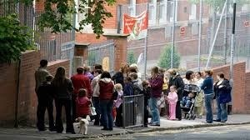
Parents MUST NOT gather or remain to chat at entry and exit points or anywhere outside the school and MUST wear face masks and socially distance at all times.

General Information
Preventing Coronavirus

The virus that causes COVID-19 is mainly transmitted through droplets generated when an infected person coughs, sneezes or speaks.
These droplets are too heavy to hang in the air. They quickly fall on floors or surfaces. The advice for schools, colleges and childcare settings is to follow steps on social distancing, handwashing and other hygiene measures and cleaning of surfaces.
The Department for Education and Public Health England and Wales state.
Children are likely to become infected with coronavirus (COVID-19) at roughly the same rate as adults, but the infection is usually mild.
The most common symptoms of coronavirus (COVID-19) are a new, continuous cough or a high temperature (over 37.8 degrees) or loss of or change to their sense of taste and smell.
For the vast majority of children and staff, coronavirus (COVID-19) will not cause serious illness
To help ensure that the risk of virus spread for both staff and children is as low as possible, School expect all should follow the information laid out below:
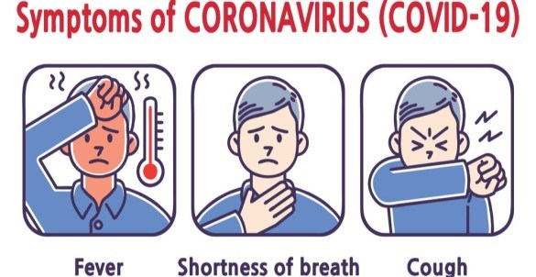
Children, parents, carers or any visitors, such as suppliers, MUST NOT enter the School if they are displaying any symptoms of coronavirus (COVID-19) or they have tested positive for COVID-19 in the past 10 days.
PARENTS/CARERS MUST NOTIFY THE SCHOOL IF ANY SYMPTOMS ARE DISPLAYED. THIS IS OF VITAL IMPORTANCE.

Social Distancing Guidelines
Social distancing within school settings with very young children is harder to maintain. Staff will implement the above measures as far as they are able, whilst ensuring children are kept safe and well cared for within their settings.
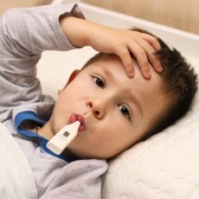
Parents/Carers have a responsibility to monitor their own child’s health and MUST NOT send their child to school if they or themselves have a persistent cough, high temperature or any COVID-19 symtoms.
First Aid
If attending to any wounds etc., staff will use personal protective equipment (PPE at all times. A visor, gloves and aprons are available for use by staff.
Parent/Carers are required to give permission for learners to attend doctor’s surgery or hospital. Please ensure all medical forms are completed and returned to the school office.
Priorities for learning in March
health and well-being: learning should support learners’ mental, emotional,
physical and social well-being as well as recognising the importance of outdoor
learning and play
• purpose: all learning should have a clear purpose in mind, focused around what
is important for learners now and in the longer-term
• literacy, numeracy and digital competence: learners should have
opportunities to develop and apply these skills across the curriculum
• broad and balanced: learners should have learning experiences which span a
broad curriculum and which includes opportunities to develop a breadth of
understanding and a range of knowledge and skills
• progression and assessment: learners should make meaningful progress
throughout this period. Learning should be designed to support increasing depth
and sophistication of learning over time. We encourage the use of assessments
to help learners move to the next steps in their learning
Foundation Phase
Teachers and other staff will use age and developmentally appropriate ways to encourage children to follow social distancing, hand-washing and other guidance, including through games, songs and stories. Parents/carers must reinforce these messages at home, reminding their children to support the school in establishing good routines for handwashing and social distancing.
We hope that you find this information informative, helpful and reassuring. We thank you for your continued support.

If you have any questions or require further information, please email bfmail@hwbmail.net or telephone the School on 01352 713184.

