Brynford CP School
Brynford
Holywell
Flintshire
CH8 8AD
01352 713184

Ysgol Gynradd Brynffordd
Brynffordd
Treffynnon
Sir y Fflint
CH8 8AD
01352 713184
‘Every child, every chance, every day’
‘Pob plentyn, pob cyfle, pob dydd’
Mrs Rachel Critchell B.A.HONS P.G.C.E, NPQH
bfmail@hwbcymru.net
Returning to School
Parental Information

The School Day

- In January 2022 the School Day will start at 8:55 and end at 3:20.
- Reception 8.55 until 3.15. Nursery and Early Entitlement pupils will arrive at 12.45 and leave at 3.15.
- Class 1 (Year 1&2) pupils arrive 9.00, leave 3:20.
- Class 2 (Year 3&4) pupils arrive 8.55 leave 3.15.
- Class 3 (Year 5&6) pupils arrive 9.00 leave 3:20.

- Please ensure you arrive promptly. If you are late arriving, you must wait at the gate and telephone the school office on 01352 713184. Either Mrs Critchell or Mrs Prytherch will collect your child from the gate.

- All children should attend school in January 2022 if they are well. Latest advice regarding shielding adults and children will be adhered to. Please refer to the link for information:

However, if your child is unwell, please notify the school with your child / children’s name and the reason for absence by telephone 01352 713184 or email bfmail@hwbcymru.net by 8.30am.

- ONLY Children and Staff are able to enter the School site. Access for Parents, Carer’s, Visitors etc. is strictly by appointment only.

- Pupils are to wear school uniform in January 2022 apart from P.E days, when children should come to school dressed in PE kit. Long hair must be tied back and no jewelry can be worn.

P.E days will be as follows;

- Reception; Monday

- Class 1 Tuesday and Wednesday.

- Class 2 Tuesday and Thursday

- Class 3: Monday and Friday

PE kits should consist of black leggings/ black jogging bottoms, white t-shirt, school jumper, trainers.

- Entry and Exit to and from School will be for pupils only via the following access points.

- Class 3 Groups (year 5 and 6): Enter through the car park gate onto the school yard, walk to the designated waiting point, ensuring social distancing.

- Class 2 Groups (year 3 and 4): Enter through the front car park gate onto the school yard, walk to the designated waiting point, ensuring social distancing.

- Class 1 Groups (year 1 and 2): Enter through the front pedestrian gate onto the school yard, walk to the designated waiting point, ensuring social distancing.

- Reception Group: Enter through the front pedestrian gate onto the school yard, walk to the designated waiting point, ensuring social distancing.

- Nursery and Early Entitlement Groups: Wait at the front pedestrian gate until collected by the Teacher at 12.45pm. They will leave through the front pedestrian gate at 3.15pm.

- Designated waiting points will be supervised by staff at the start and end of the day.

- Snack will not be provided by school so children will need to bring their own healthy snack. This should be in packaging that is easily opened by your child.

- Children may bring a pack of tissues and hand sanitizer. These items will be for their own use only.

- Please only bring necessary items to school. These include a drinks bottle, medication (which will remain in School) and a coat. PLEASE DO NOT send in school bags.

- School will minimise the sharing of food, drink, utensils, equipment and toys. Equipment, toys and surfaces will be cleaned and disinfected more frequently. Each child will have designated for their own use.

- As far as possible, pupils and staff will maintain some social distancing. This is within school and outside.

- Classrooms will be organised with children sitting side by side and facing forwards. Staff will maintain 2 metre social distancing whenever possible.

- Movement through the corridor will be minimised and a keep left system is in operation.

Procedures for illness

If any child shows any signs of illness, they will be separated from other children and will wait in the School foyer supervised by a member of staff wearing PPE. Parents will be contacted immediately and will be required to collect their child immediately. Surfaces that learners or staff with symptoms have come into contact with will be carefully and thoroughly cleaned.

Children or staff should not attend school:
if they feel unwell, have any of the three main identified COVID-19 symptoms:
- a high temperature: this means that they feel hot to touch on their chest or back
- a new, continuous cough: this means coughing a lot for more than an hour, or 3 or more coughing episodes in 24 hours
- a loss or change to their sense of smell or taste: this means they’ve noticed they cannot smell or taste anything, or things smell or taste different to normal.

If you have symptoms of COVID-19

- If you have any of the main symptoms of COVID-19 and are over 5 you should self-isolate and book a PCR test as soon as possible. This applies even if you have mild symptoms or if you have tested positive before.
- Anyone displaying symptoms or receiving a positive PCR or LFT should self isolate for at least 7 days. On day 6 and 7 of isolation, the indivdual should take a lateral flow test. If both results are negative, the indivdual can leave self isolation after 7 full days of isolation ( day 8 of your self- isolation period.) If either of the tests taken on day 6 or 7 are positive, the individual should continue to self- isolate until he/ she has two negative lateral flow tests ( taken 24 hours apart) or 10 days have passed from the original positive test ( whichever is soonest.)
• Anyone who lives with someone displaying symptoms or testing positive must LFT test every day for 7 days.
Test,Trace,Protect works by;

Testing those people who have coronavirus symptoms, asking them to self isolate from family, friends and their community whilst taking a test and waiting for a result. People can apply for a test for themselves or someone in their household with symptoms. This includes adults and children over the age of 5’s. The current Government guidance does not recommend the testing of under 5’s, however:

Children under the age of 5
Children under 5 do not need to take a PCR or a LFT, even if they have COVID-19 symptoms. They can take a test if a doctor advises it, or if a parent believes a test is absolutely necessary and in the best interests of a child.
If they have symptoms or if they have been a close contact of a positive case, they do not need to complete any mandatory period of self-isolation. They should stay home until they are well enough to return to school or childcare setting.
If a child under 5 has symptoms, other household members do not need to isolate unless the child takes a test and has a positive result. If a child does take a test and the result is positive, then the child must self-isolate for at least 7 days and the child and contacts need to follow the self-isolation guidance.
Tracing those people who have been in close contact with people that have tested positive for the virus, requiring them to take precautions through self isolation
Ensuring that if the symptoms are not due to coronavirus following a negative PCR, individuals and their contacts can get back to their normal routines as quickly as possiible
A positive test on site does not require closure of the site. The process of testing and contact tracing is part of the ‘new normal.’

Fully vaccinated adults and young people aged between 5 and 17 if a close contact.
If you are a fully vaccinated adult or aged between 5 and 17 you do not need to self-isolate if identified as a close contact but you are strongly advised to:
- take a LFT every day (unless you cannot conduct an LFT for medical reasons) for 7 days or until 10 days since your last contact with the person who tested positive for COVID-19 if this is earlier
- take this daily test before you leave the house for the first time that day
- upload all tests results on GOV.UK even if negative or void. This helps improve our understanding of infection rates across the UK and helps inform how we manage the pandemic to keep people safe whilst keeping life as normal as possible

Clusters and Outbreaks
A potential cluster is defined as two or more cases of COVID-19 among learners or staff in a class within 10 days, the school will contact FCC.
If there is more than one positive case of Covid-19 associated with a school the local TTP service / Environmental Health Officer will consider if these cases appear to be linked. Environmental Health where appropriate will be informed if there appears to be multiple cases of Covid-19 in a school.

In preparation for your child/children returning to school in January 2022
Parents/Carers please discuss these messages at home, reminding your child/children to support the school in continuing to establish good routines for handwashing and social distancing.

For January 2022; This means;
The classrooms will be organised with forward facing desks, with children sitting side by side in Key Stage 2. Staff will maintain 2 metre social distancing wherever possible.
Each child will have all the supplies they need on their desk for the period they are in school. Please do not bring unnecessary items into school. A water bottle, medication, snack and packed lunch bag is all that is required.
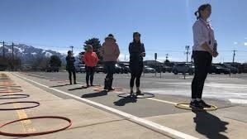
Everyone queues and maintains some social distancing at the start and end of the day.

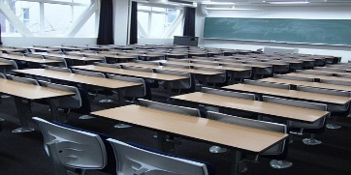

We all follow the keep left system around school
Eat on designated tables (class groups) in the hall.

social d
We maintain some social distancing when in the playground or doing any physical exercise with classes.

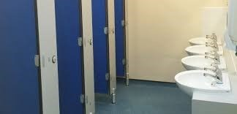
Visiting the toilet one after the other. Each Class will have a designated cubicle.

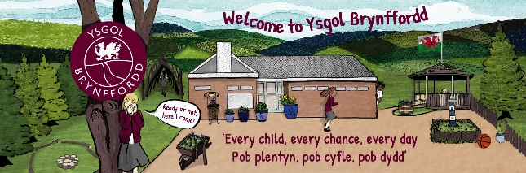
Each group will have a designated area for any break times or outdoor learning. Break times will be staggered for Foundation Phase and Key Stage 2.

Antibacterial wipes and spray will be used throughout the day with all classes and toilets being thoroughly cleaned at the end of each school day.

Children must arrive at school by walking or in private vehicles only.

Class groups will remain with the same staff members where possible, in well ventilated rooms with CO2 levels monitored. They will have appointed play areas on the yard.
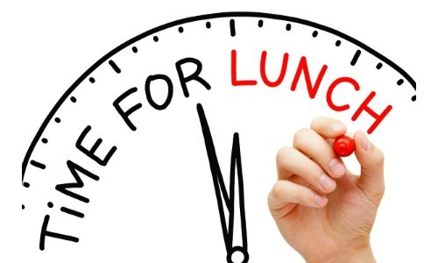
Lunch and snack will be eaten at designated group tables in the hall, with break times and outdoor learning taking place in the class areas. All outdoor learning and lunchtimes will be staggered. Regular handwashing routines will be established.

All staff and children will:
- Wash their hands with soap and water for 20 seconds frequently. (e.g. on entry to the building, before and after eating, after breaktimes/lunchtimes
- Will be encouraged not to touch their faces
- Use a tissue or elbow to cough or sneeze and use designated bins for tissue waste
- All staff will ensure help is available for children and young people who have trouble washing their hands
- Use hand gel throughout the school day
- Staff will wear face coverings in communal areas and classrooms where social distancing cannot be maintained
- Staff will LFD Test 3 times per week, Monday Wednesday and Friday mornings.

Cleaning
There will be increased cleaning of surfaces in classrooms, including desks and handles, and within toilet blocks and changing rooms throughout the day.
Where possible, all classes will use designated toilet cubicles. Toilets will be regularly checked for cleanliness.
For children and young people with an individual care plan, teaching staff as well as parents will work together to decide how best to continue supporting these children and young people to stay healthy.
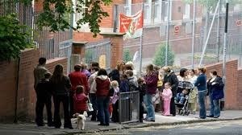
Parents should not gather at entry and exit points or anywhere outside the school.
Parents are asked to wear face coverings unless medically exempt and to socially distance at all times.
General Information
Preventing Coronavirus
The virus that causes COVID-19 is mainly transmitted through droplets generated when an infected person coughs, sneezes or speaks.
These droplets are too heavy to hang in the air. They quickly fall on floors or surfaces. The advice for schools, colleges and childcare settings is to follow steps on social distancing, handwashing and other hygiene measures and cleaning of surfaces.
The Department for Education and Public Health England and Wales state.
Children are likely to become infected with coronavirus (COVID-19) at roughly the same rate as adults, but the infection is usually mild.
The most common symptoms of coronavirus (COVID-19) are a new, continuous cough or a high temperature (over 37.8 degrees or hot to the touch) or loss / change to their sense of taste and smell.
For the vast majority of children and staff, coronavirus (COVID-19) will not cause serious illness
To help ensure that the risk of virus spread for both staff and children is as low as possible, School expect all should follow the information laid out below:
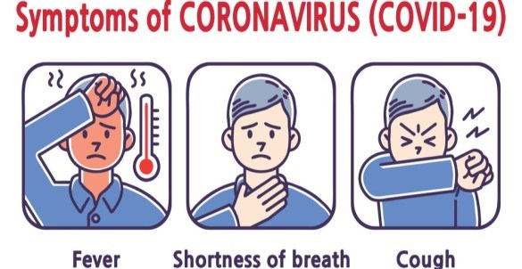
- Children, parents, carers or any visitors, such as suppliers, MUST NOT enter the School if they are displaying any symptoms of coronavirus (COVID-19) Anyone displaying symptoms or receiving a positive PCR or LFT should self isolate for at least 7 days. On day 6 and 7 of isolation, the indivdual should take a lateral flow test. If both results are negative, the indivdual can leave self isolation after 7 full days of isolation ( day 8 of your self- isolation period.) If either of the tests taken on day 6 or 7 are positive, the individual should continue to self- isolate until he/ she has two negative lateral flow tests ( taken 24 hours apart) or 10 days have passed from the original positive test ( whichever is soonest.)
PARENTS/CARERS MUST NOTIFY THE SCHOOL IMMEDIATELY BY EMAIL IF ANY SYMPTOMS ARE DISPLAYED OR A POSITIVE TEST IS RECEIVED.

Social Distancing Guidelines
Social distancing within school settings with very young children is harder to maintain. Staff will implement the above measures as far as they are able, whilst ensuring children are kept safe and well cared for within their settings.
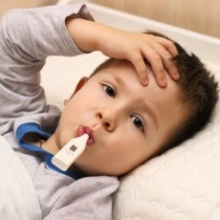
Parents/Carers have a responsibility to monitor their own child’s health and MUST NOT send their child to school if:
- a high temperature: this means that they feel hot to touch on their chest or back
- a new, continuous cough: this means coughing a lot for more than an hour, or 3 or more coughing episodes in 24 hours
- a loss or change to their sense of smell or taste: this means they’ve noticed they cannot smell or taste anything, or things smell or taste different to normal.
First Aid
If attending to any wounds etc, staff will use Personal protective equipment (PPE at all times. A visor, gloves and aprons are available for use by staff.
We hope that you find this information informative, helpful and reassuring.

If you have any questions or require further information, please email bfmail@hwbcymru.net or telephone the School on 01352 713184.

