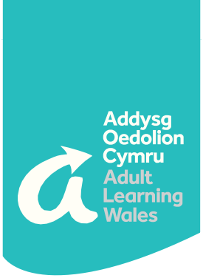

Courses in March-April

**Help your child with maths** Tuesdays and Thursdays | 2 x 1 hour sessions   
**Help your child with reading** Tuesdays and Thursdays | 4 x 1 hour sessions

**Course Overview**These courses will help dads, mums, grandparents and carers help children with their reading and number skills. You will learn lots of handy hints to take away and have fun practising with your child.

**The courses include:**

* Fun with letters and words
* What, when and where to read?
* What are phonics and how to practise them?
* Fun with shapes
* Rhymes, games and songs
* How does my child learn maths at school?

**What Do I Need?**You will need an iPad or a laptop as this is an online course. You will also require Internet access.

Click here for available dates and to sign up:

[**https://www.adultlearning.wales/en/courses/course-results?&subject=supporting-families**](https://www.adultlearning.wales/en/courses/course-results?&subject=supporting-families)

[**info@adultlearning.wales**](mailto:info@adultlearning.wales) **| 03300 580845 | adultlearning.wales**

The National Community College

Rydym yn annog a chroesawu gohebiaeth a galwadau ffôn yn Gymraeg a byddwn yn ymateb i’ch dewis iaith   
We encourage and welcome correspondence and phone calls in Welsh and will respond to your language choice

**Online Course**