Brynford Primary /
Ysgol Brynffordd
Brynford Primary
Brynford
Flintshire
CH8 8AD
01352 713184
Email: bfmail@hwbcymru.net
Website: ysgolbrynffordd.cymru

[Insert name of Head]

Site Traffic Management
Plan

September 2022
September 2023

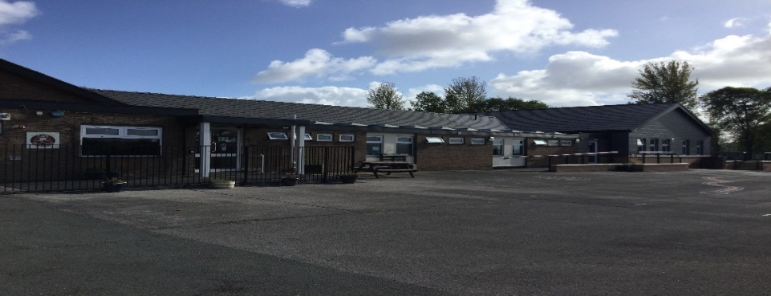
Contents

1 Introduction 2
2 School Layout/ Access 2
3 Pedestrians 2
4 Pupils 3
5 Staff 4
6 Visitors 5
7 Servicing / Deliveries 5
8 School Buses 6
9 Contract Hire Services 6
10 Disabled Access 7
11 Outwith the School Grounds 7
12 Management Practices 7
13 Appendix A 9

Introduction
This document has been prepared to inform and instruct employees, pupils, parents and others who come onto the site, including visitors (both pedestrians and people in vehicles), about the site rules concerning pedestrian and vehicle separation.

[Insert school name] takes the health and safety of all site users very seriously. It is therefore, imperative that individuals take care, exercise caution when in the school grounds or within the vicinity of the school grounds and follow instructions to avoid risk of injury. If there are any concerns about traffic safety, they should be reported to the school management team.

We urge all site users to read this document carefully and act in accordance with the instructions contained therein. The instructions constitute site rules. Pupils in breach of the site rules may be subject to disciplinary action.

Following a review of the usage of car park and surrounding area, physical changes have been implemented. This document takes account of these changes and refers to the new layout and access rules that will be completed by November 2022.

Copies are also available from reception and on the school website: ysgolbrynffordd.cymru

The document will be reviewed annually and awareness raised regularly through parental events, pupil sub-groups, assemblies and school meetings.

For further information, please contact:

Mrs Rachel Critchell Headteacher or Mrs Prytherch School Secretary on 01352 713184, in writing or by email to bfmail@hwbcymru.net.

School Layout/ Access

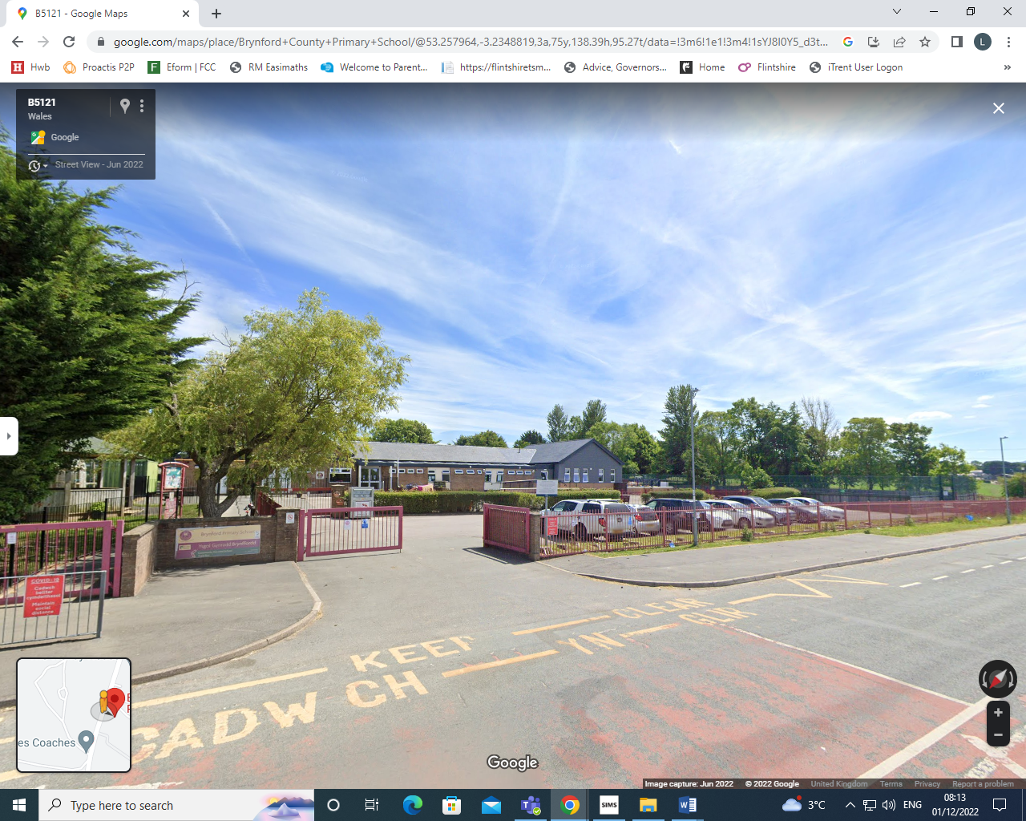

Pedestrians
There is a pavement to the front of the school and pedestrians should make sure that they use this safely and avoid spilling onto the road. Pupils walking in groups should take this into account and allow other users to pass safely.

Pedestrians should only access the school from the designated entry point which is the front pedestrian gate with Intercom access. Pedestrians need to recognise that these may be adjacent to vehicular access points that will be in use during peak times and should exercise caution.

Designated Entry Points

Pedestrians should follow the local footpaths along Lixwm Road where there is a pedestrian entry points located at the front of the school, this is the front pedestrian gate with Intercom access. The vehicular access should not be used by pedestrians. Entry into the school building is through the main entrance.

Pupils
It is very important that pupils set a good example to others, particularly in the spirit of being a safe school. There are a number of site related areas pupils should be aware of:

- Pupils should be particularly aware that entry into the school ground via vehicular access points (school car parks, Bus Park and the service area) is strictly forbidden. Whilst this may seem a quick way into the school, it is a breach of the site rules and compromises personal safety and the safety of others.

- Pupils found to be climbing over railings, not following staff instructions in relation to the site, or not adhering to the contents of this plan will be in breach of the site rules and may be subject to disciplinary action.

- When using the footpaths – walk! This will avoid accidents and will make you more aware of what is happening around you.

- Pupils cycling to school must enter the grounds via the pavement from Lixwm Road into the school grounds by the front pedestrian gate, having dismounted from their bicycles first. They should exit the school via this same route for Reception to Year 2 and with a supervising member of staff via the car park for years 3 to 6.

- If pupils are accessing the school before the school day, entry into the building is only permitted via the main entrance doors. Entry using any other door is not permitted as this would require you to cross the areas that are out of bounds.

Drop Off

There is no designated on site drop off for pupils, however the layby at the front of the school can be used for this purpose. No vehicle should be accessing the car parks for this purpose, without express permission. It is not recommended that the side road off Lixwm Road up to Hafod Y Bryn be used for pick-ups/drop offs.

Staff & Visitors
Access or exit by vehicles into or out of the car park are prohibited between 3pm and 3.30pm on all school days. There is one car park within the school grounds. This car park is strictly for the use by school staff, supply staff and authorised visitors to the site, there is also a disabled bay. Drivers should proceed slowly within the car parks at all times. Please bear in mind that some young people and some pupils with additional support needs may have little or no awareness of road safety and you should take account of this.

Staff are expected to act responsibly on the site when parking and accessing the school building. If you are aware of unauthorised use of parking bays, this should be reported via the School Secretary who will inform/remind the offending driver of the correct use of the site.

Staff, Visitors, Disabled & Deliveries

This car park is used by a number of vehicles - staff, authorised visitors and deliveries. Staff should enter the building the main entrance using their key fob. Visitors/deliveries should make their way to the front side pedestrian gate which has Intercom access, once buzzed in proceed to the main entrance via the path and push the button to open the main entrance automatic doors. If any information is required prior to arrival please contact the school office on 01352 713184.

Outside the School Grounds
Parking indiscriminately, such as mounting pavements, double parking, stopping on any yellow lines, obstructing access points to streets and driveways and parking near junctions causes danger to pupils and other road users. Accidents can arise if views are obstructed or pedestrians have to negotiate between parked vehicles. In addition, the roads can become congested which results in frustration and delays to services and ongoing journeys.

Management Practices
Key to the ongoing monitoring of the plan is the role of school managers and other staff. All staff have a responsibility to make sure that they are acting in such a way as to not compromise the health and safety of themselves or others.

Supervision
The Senior Management Team will arrange for daily supervision at the end of the school day.

Monitoring of compliance against this plan
In addition to the supervision arrangements in place, Senior Management Team will carry out weekly site inspections to view practices. These inspections will be recorded on the ‘weekly site monitoring form’ (see appendix A). These records will be retained for 6 months.

Where issues arise with vehicular access, taxi/minibus drivers and staffing, these will be dealt with or escalated by the School Secretary. The Senior Management will be responsible addressing the conduct of all pupils where this is not consistent with the requirements of this plan.

Non-compliance
If there are concerns or incidents that constitute non-compliance these will be recorded on the form by those monitoring the site and appropriate action will be taken. This includes possible disciplinary action and reports going to Contractor or Service management which may result in investigative action. On days where there is no monitoring carried out and there is an instance of non-compliance, these should be escalated immediately to the Senior Management Team who will make a record on the form and take appropriate action.

Appendix A
Traffic Management Plan - Weekly Site Monitoring Form

Completed by: Senior Management Team
Date | Area | Observations | Incidents | Signed by

