Brynford School & FOBS
Thursday 21st March 5.00pm – 6.30pm (ish)
Come and join the FOBS Easter Bingo night at Brynford School to raise vital funds for the school.
Tickets are £5 per person for a book of 6 games of Bingo (6 cards per game) and a bingo dabber. All the Bingo prizes will be Easter themed. Additional Bingo game books will be available to buy on the night for those who want to work more than one book!
As well as Bingo there will be an Easter raffle and a tuck shop where you can buy refreshments. All proceeds from the evening will go towards providing equipment, trips and enhanced experiences for the pupils of the school.
Please RSVP on the attached form by Thursday 14th March so we know how many to cater for. NB Friends and family are all welcome!!!
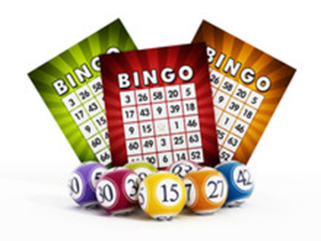

Name of pupil __________________________________________

We will/ will not be coming to Bingo night.

Number of people attending (@ £5 per person) ________________

Name of parent _________________________________________

Signature of parent_______________________________________

By returning this form I understand that I will pay £5 per person (based on the numbers indicated by me above) to participate on the Bingo night and will pay this on arrival at the evening.

